Changes in the current website
Home Page | - Fevicon is missing-- Need a Fevicon Icon  - Finkeep Logo’s size should be increased -- Done  - Navigation section elements are to be changed:  - Home menu to be converted into a home icon -- Done  - New menu options to be – Need Explanation  - Product features  - Offerings  - Success story  - Icons: -- Where ??  - Instagram  - Linkedin  - Contact us  - Home  - Button: Login/Register --- Pending  - Finkeep Button (Let’s Finkeep): Please change the color to a lighter shade like bench. --- Done  - Lets finkeep to redirect to products page and not to open that dialogue box -- Done  - We use tally as our accounting software -- OK  - 5th Point of welcome to finkeep shall be (Financial management, advisory & internal control) -- Done  - Add:  - A heading on the users: How do you benefit from us. -- Where???  - Industry Served. -- Where???  - Testimones:  - Give equal sizzing to the testimones boxes (reduce the text content). -- Done  - Change testimones photo. -- Pending  - Use accordion in FAQs section & take reference from Suvit. (https://www.suvit.io/about) -- Done  - Footer icon’s color to be changed. -- Please choose icons and send    Instead of this, please use integrated with tally picture in place of this -- Done      For water mark in professional affiliates: Use https://www.flaticon.com/free-icon/office-worker_3502880?term=office&page=1&position=10&origin=search&related_id=3502880    For water mark in professional affiliates: https://www.flaticon.com/free-icon/businessman_998463=term=professional&page=1&position=2&origin=search&related_id=998463 group=all&word=professional&license=&color=&shape=&current_section=&author_id=&pack_id=&family_id=&style_id=&type=for chartered accountants      https://www.flaticon.com/search?type=icon&search-group=all&word=office&license=&color=&shape=&current_section=&author_id=&pack_id=&family_id=&style_id=&type= for Accounting firms  - Picture for FAQ.  Replace this photo FAQ with    This FAQ image    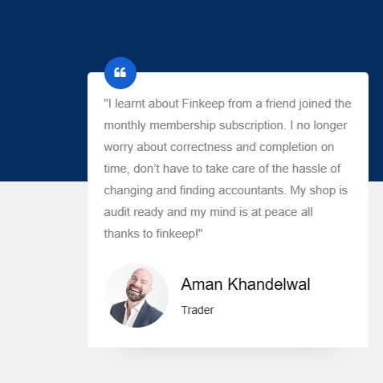  Use the below text in place of the above one for paragraph adjustment.  Introduced to Finkeep by a friend, I joined the monthly subscription, eliminating worries about correctness and completion. No more hassle changing accountants; my shop is audit-ready. Thanks to Finkeep, my mind is at peace. -- Done
Product bundle page | - Make the image height and text height equal in annual accounting, periodical accounting, clean up accounting, integration and mis reporting section. -- Need Explanation  - Relocate the SOW Finkeep button to the lower right corner across all four sections. -- Done  - Add pricing feature as shared to sheesheer. -- Working on it  - Rename product bundle page as OFFERING. -- Done  
Product Features | - Selecting Icons.
Chacha discretion | - Please decide on the color contrast of the website  - Is Navigation bar’s color transition soothing well?  - Picture for FAQ.
 | - About us & Product bundles bar

